Circle Language Spec: Relations

Dual & Unary in a Diagram
The concept of dual and unary is explained in the articles Dual & Unary, Related Classes and Relations.
The expression of dual and unary in a diagram has already been introduced in the articles Related Classes in a Diagram and Relations in a Diagram. This article only puts the diagram expressions of dual and unary next eachother for a comparison.

This is a unary relation between Class A and Class B:

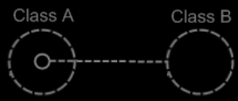

This is a dual relation between Class A and Class B:

